UNIT 3
Lesson 7 – AN INTERVIEW
- 1 a) Look at the pictures and read the expressions.
Promotri slike i pročitaj izraze koji ih opisuju.
.

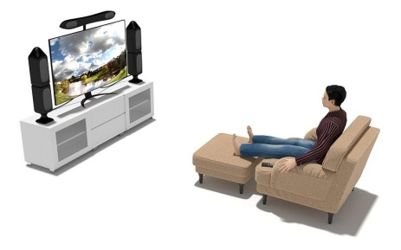
watch TV
gledati TV
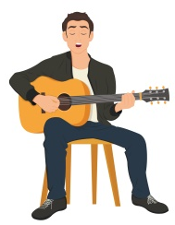
play a musical instrument
svirati instrument
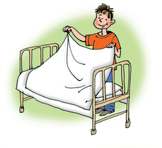
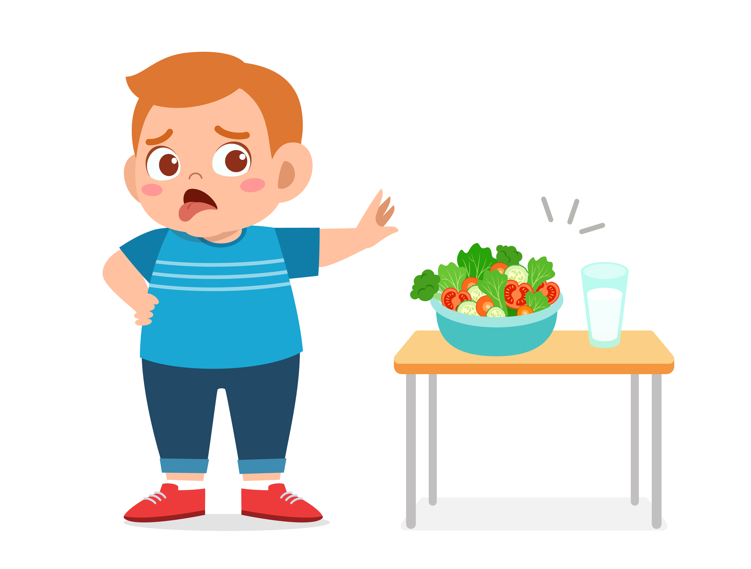
skip breakfast
preskočiti doručak

make the bed
namjestiti krevet


go out with your friends
izlaziti s prijateljima


get up early eat sweets
rano se ustati jesti slatkiše


talk back to your parents
odgovarati svojim roditeljima


have a birthday party
slaviti rođendan


read messages before bed
čitati poruke prije spavanja

b) Match the expressions to the pictures.
Spoji izraze s odgovarajućim slikama.

 watch TV

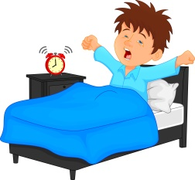 read messages before bed

go out with your friends
 have a birthday party get up early

c) Match the expressions to the pictures.
Spoji izraze sa odgovarajućim slikama.

make the bed

skip breakfast

eat sweets
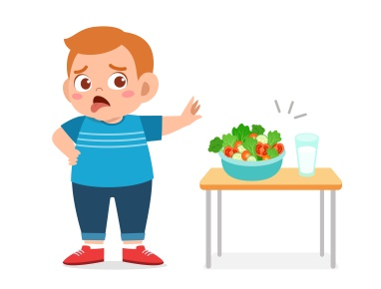 play a musical instrument

talk back to your parents

d) Put the right word to make a question.
Na praznu crtu upiši točnu riječ tako da dobiješ pitanje.
read play watch get up eat make skip go have talk

1 Do you________ TV in the morning?
Gledaš li TV ujutro?

2 Do you________ the bed before school?
Pospremaš li krevet prije odlaska u školu?

3 Do you ________ a musical instrument?
Sviraš li glazbeni instrument?

4 Do you ________ out with your friends?
Izlaziš li vani s prijateljima?

5 Do you________ early on Sunday?
Ustaješ li rano nedjeljom?

6 Do you ________ back to your parents?
Odgovaraš li svojim roditeljima.

7 Do you ________ party for your birthday?
Priređuješ li rođendansku zabavu za svoj rođendan?

8 Do you ________ breakfast?
Preskačeš li doručak?

9 Do you ________ sweets?
Jedeš li slatko?

10 Do you ________ your messages before bed?
Provjeravaš li poruke prije spavanja?

e) Ask your friends questions from task 1 c).
Put a tick if he / she answered with yes.
Pitaj svog prijatelja iz razreda pitanja iz zadatka 1 c). Stavi kvačice u prazne kućice pored pitanja na koje je tvoj prijatelj odgovorio potvrdno.

f) What about you? What do you do?
Write what you do. Find help in task 1 d).
Koje su tvoje navike? Napiši što ti radiš.
Pronađi pomoć u zadatku 1 d).

1 I ___________________________________________ .
2 I ___________________________________________ .
3 I ___________________________________________ .
4 I ___________________________________________ .
5 I ___________________________________________ .

- 2 a) Click is a school magazine.
Anna is a schools journalist.
Listen to her interview with Mr Holland (3.8.).
What subject does Mr Holland teach?
Circle the correct answer.
Click je školski časopis. Anna je školski novinar.
Poslušaj njezin intervju s godpodinom Hollandom.
Koji predmet podučava gospodin Holland?
Zaokruži točan odgovor.

1 Mr Holland teaches maths / art.
Mr Holland podučava matematiku / likovni.

b) Listen to the interview once again.
Circle the words you hear.
Poslušaj intervju još jednom. Zaokruži riječi koje čuješ.

geography art
sporty lazy
karate football tennis
rock music pop music classical music
guitar piano
Mondays Saturdays
girlfriend friend
Bonnie Billy
history maths
cinema disco concert
spaghetti pizza
running sleeping

c) Listen to the interview again.
Read the sentences.
Circle the correct word to make a true sentence.
Poslušaj intervju još jednom. Pročitaj rečenice.
Zaokruži riječ tako da dobiješ točnu rečenicu.

1 Mr Holland teaches PE / art.
Gospodin Hollland podučava TZK / likovni.

2 Mr Holland does karate and plays football / tennis.
Gospodin Holland trenira karate i nogomet / tenis.

3 He loves / hates rock music.
On voli / mrzi rock muziku.

4 He plays the violin / piano.
On svira violinu / piano (klavir).

5 Mr Holland collects old CDs with pop / rock music.
Gospodin Holland sakuplja CD-e pop / rock muzike.

6 He hoes out with his mum / girlfriend.
On izlazi sa svojom mamom / djevojkom.

e) Copy the correct sentences from task 2 c).
Prepiši točne rečenice iz zadatka 2 c) na prazne crte.

1_____________________________________________
2_____________________________________________
3_____________________________________________
4_____________________________________________
5_____________________________________________
6_____________________________________________

